GLFW is a lightweight utility library for use with OpenGL. GLFW stands for Graphics Library Framework. It provides programmers with the ability to create and manage windows and OpenGL contexts, as well as handle joystick, keyboard and mouse input

Just a library to create and manage window

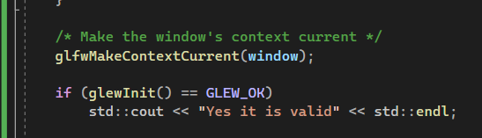

Always use the glewInit( ) after the glfMakeContextCurrent(window)

Otherwise it might give error later on